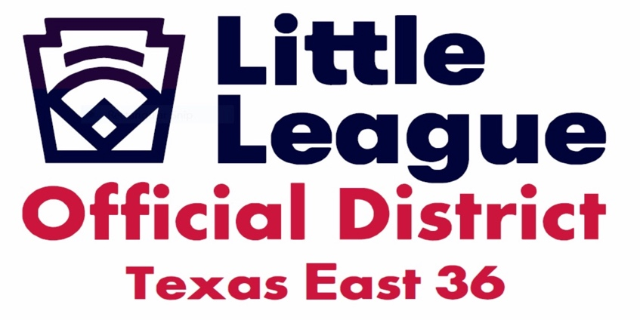
Welcome to the TX East State Little League Tournament
Hosted by TX East District 36
Things to know
To all of you whom it may concern District 36 was established in 2021 after becoming a split of the once 24-League District 18.
District 36 is now comprised of 10 Leagues Alvin, Angleton, Brazoria, Brazoswood, Damon, Lamar, Needville, Rosenberg, Sugarland, West Sugarland.
The venues hosting the divisions
Seniors Division:
- Rosenberg Little League Founded in 1964,
President, Paul Morales
Host Site: Rosenberg Little League
Seabourne Creek Regional Sports Complex
Juniors Division:
- Lamar Little League Founded in1955.
President, Justin Pollard
Host Site: George Park
2155 Collins RD
Richmond, TX

Intermediate 50/70 Division:
Host League: Rosenberg Little League
Site:
- The Diamonds at Daily Park
1903 Daily Rd.
Rosenberg, TX

RULES, GUIDELINES and FIELD DETAILS
ALL VENUES
- NO ALCOHOL OR TOBOCCO PRODUCTS
- CONCESSIONS WILL BE AVAILABLE AT ALL VENUES
*Exceptions Team Cooler with Water, and Drinks.
- NO OUTSIDE DRINKS OR FOOD

AT ROSENBERG LITTLE LEAGUE
- COMPLEX: SPACIOUS PLENTY OF ROOM FOR CANOPIES & LAWN CHAIRS.
- BLEACHERS WITH SHADE AVAILABLE
- DIRT INFIELD
- NATURAL GRASS OUTFIELD
- PORTABLE PITCHING MOUND NO METAL CLEATS
TURF OR MOLDED RUBBER SHOES ONLY
- PLENTY OF FREE PARKING DONATIONS ACCEPTED

AT GEORGE PARK LAMAR LL
ALL OF THE ABOVE APPLIES.
Exception: DIRT MOUND METAL CLEATS ALLOWED

AT THE DIAMONDS AT DAILY PARK
- FIELD: ALL TURF NO METAL CLEATS
- PORTABLE MOUND
- RUBBER MOLDED OR TURF SHOES ONLY
- ENTRY FEE
- $10 PER PERSON DAILY
- $20 PER CAR DAILY
- 1 MANAGER & 2 COACHES ALLOWED PER TEAM
Will be verified by gate attendant.

THE BEST TO ALL OF THE TEAMS AND MAY ALL YOUR DREAMS OF WINNING A STATE CHAMPIONSHIP
ADVANCING TO A REGIONAL TOURNMENT AND A WORLD SERIES COME TRUE!!

TX East District 36
District Administrator

BOBBY ZEPEDA
832-315-1338

